August 21, 2023

Attn: John Clark, ADEC Quality Assurance Officer and Laura Eldred, Section Manager

Hello Laura and John,

We are writing to inquire on a technical detail related to the Kenai River Baseline Water Quality Monitoring program. Please feel free to direct us to another ADEC staff member or literature source if appropriate.

In our recently re-written and renewed Quality Assurance Project Plan[1], we updated QA/QC methods to follow ADEC’s own methods described in a field report from the ADEC Soldotna office that examined field data from the Kenai River 2021-2022 (Apsens and Petitt 2021)[2]. We are currently in the process of synchronizing our Kenai Baseline project data with the EPA Water Quality Exchange (WQX).

We would like to clarify the QA/QC steps that ADEC uses to flag data that does not meet standards for Relative Percent Difference; and we will use these same criteria in assessing and synchronizing our own past and future data[3]. On the following page, we have included a draft figure of a flow chart that outlines the steps for interpreting and applying data from duplicate samples, which includes a few question marks in bold text. Please let us know if this flow chart accurately encompasses the necessary considerations when deciding if data should or should not be flagged and excluded from submission to the EPA WQX. We also considered an additional ADEC document that evaluated 2017-2019 Kenai Baseline data in developing this figure[4].

Thank you again to John for joining our Technical Advisory Committee meeting earlier this year in Spring 2023. We will be meeting again in late Fall 2023 and hope that you and or any other ADEC staff are able to join again.

Thank you for your time and consideration. Sincerely,

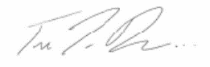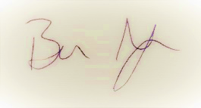

Benjamin Meyer Trent Dodson   
Environmental Scientist Executive Director  
[ben@kenaiwatershed.org](mailto:ben@kenaiwatershed.org) [executivedirector@kenaiwatershed.org](mailto:executivedirector@kenaiwatershed.org)

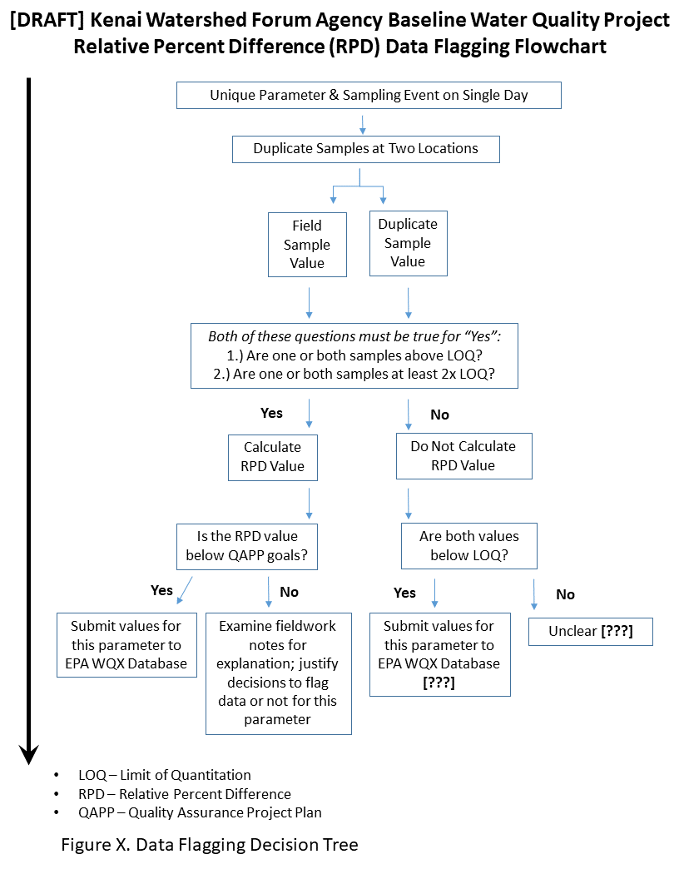

1. <https://www.kenaiwatershed.org/news-media/qapp-revisions-completed-2023/>
2. <https://dec.alaska.gov/media/25301/kenai-river-2021-monitoring-field-report.pdf>
3. <https://kenai-watershed-forum.github.io/kenai-river-wqx/appendix_a.html>
4. <https://dec.alaska.gov/media/25971/kwf-2019-kenai-cu-zn-field-report-adec-forward.pdf>